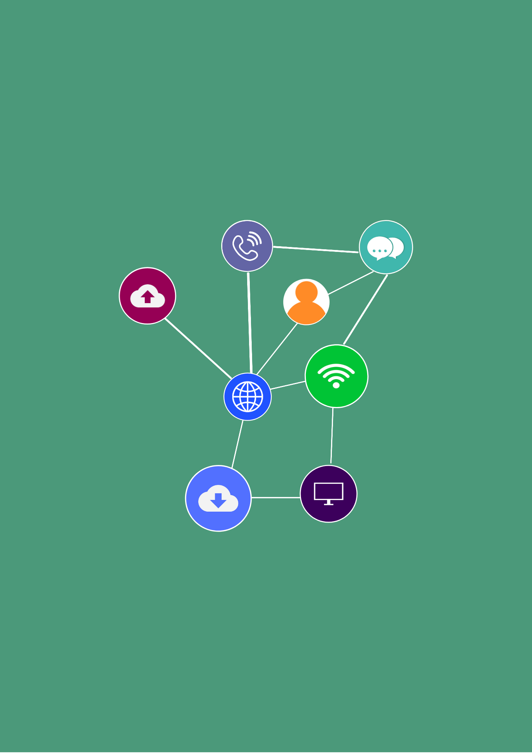
Portfolio
Student Version
ICTNWK546
Manage network security

CONTENTS
Section 1: Security design preparation 5
Section 2: Security design and policy 7

Student name:
Assessor:
Date:
Business this assessment is based on:

Section 1: Security design preparation
Network security planning
Provide an outline of the processes you will use to plan, build and manage a network security design to meet the organisation’s requirements.
ICT assets
Provide an overview of the organisation’s assets that need protecting. Remember assets are not just physical assets.
Categorise each of the assets in terms of their value. The value does not need to be a monetary value but instead can be based on the value to the organisation e.g., high, medium, low, etc.
Threat modelling
Describe at least three major threats to network security that can happen to any organisation, as well as where these threats originate from.
For each threat, describe a system vulnerability that may have led to the threat.
Risk management plan
For each of the threats you have identified, identify the level of risk that the threat presents (use a risk legend to do this).
Rank the threats in order of severity from least severe to most severe.
Outline a risk control relevant to each threat.
Use the table included in the Portfolio to develop your plan.
Presentation
Write the title of your presentation here and attach it to your Portfolio.
  Attach: | Presentation | ☐

Section 2: Security design and policy
Network security design
Provide an overview of your design to protect network security.
Include screenshots to illustrate your work as required.
Make sure you take into account manufacturer’s recommendations for use of the tools you will incorporate into your design. Write about how you have done this.
Further, include the costs of the equipment/software you have identified and document them here.
Security policies
Develop and document security policies to accompany your network security design.
Your security policy must include as a minimum:
- Purpose of the policy.
- Key procedures relevant to maintaining security e.g.,identity management, threat management (including incident response procedures) and auditing procedures.
As a guide your policy should be 2 – 3 pages. Write the name of your policy here and attach it your Portfolio.
Feedback
Write the feedback you received here and your response to it.

